Tail dependence: EURUSD and EURGBP
Method 19 / daily log returns / alpha=0.05 / Alpari D1 full available history

Study setup
Logical pair: EURUSD , EURGBP
Broker symbols: EURUSD_i , EURGBP_i
Snapshot: 2026-11-03_majors_alpari_D1
Timeframe: D1
Matched return window: 1999-01-06 to 2026-11-02 (UTC bar dates)
Matched return count n: 7183
Dropped unfinished last bar dated 2026-11-03 UTC after a tick-volume check against the prior complete day.
Uniforms: ranks/(n+1); alpha=0.05
Complete matched rows (Excel): EURUSD-EURGBP_Tail_D1.xlsx
Complete matched rows (HTML table): EURUSD-EURGBP_Tail_D1_data.html

Method carried forward
Tail dependence counts how often both legs sit in an extreme uniform tail together. Matched daily log returns of close, ln(close_t / close_t-1), become u_i = rank(x_i)/(n+1) and v_i = rank(y_i)/(n+1). At alpha=0.05, lower L_hat = (# u<=alpha and v<=alpha) / (# conditioning leg <= alpha); upper uses >= 1-alpha. Both conditioning directions are reported with numerator and denominator counts. Quotes are not inverted. L_hat(0.05) is a finite-sample frequency, not the asymptotic lambda. Same-sample Pearson r is a side check. This is not causation and not a trading signal.

Results
tail | cond | L_hat | num | denom
lower | EURGBP | 0.373259 | 134 | 359
lower | EURUSD | 0.373259 | 134 | 359
upper | EURGBP | 0.278552 | 100 | 359
upper | EURUSD | 0.278552 | 100 | 359
Pearson r on returns: 0.439899

Conclusion
Over 7183 matched daily rows for EURUSD and EURGBP at alpha=0.05, lower L_hat conditioning on EURGBP is 0.3733 (134/359); conditioning on EURUSD is 0.3733. Upper L_hat conditioning on EURGBP is 0.2786; on EURUSD is 0.2786. Pearson r = 0.4399. These are finite-sample frequencies, not asymptotic lambda and not a trading signal.

Charts
Daily closes

Daily log returns

Uniforms with alpha lines
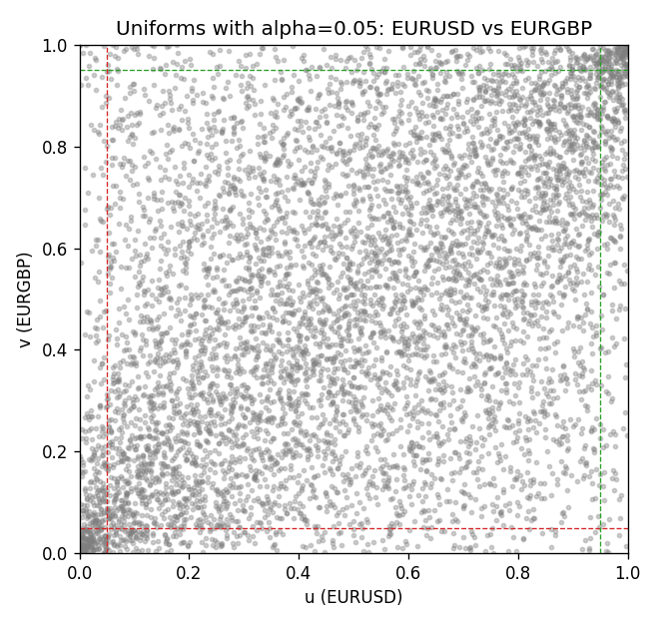

Data report
Every matched row is stored in the sibling Excel workbook named EURUSD-EURGBP_Tail_D1.xlsx, including u and v. Embedding all rows as a Word table is impractical; this file holds column summaries and the first and last 15 matched rows.
Columns: time, EURUSD_open, EURGBP_open, EURUSD_high, EURGBP_high, EURUSD_low, EURGBP_low, EURUSD_close, EURGBP_close, EURUSD_tick_volume, EURGBP_tick_volume, EURUSD_spread, EURGBP_spread, EURUSD_real_volume, EURGBP_real_volume, EURUSD_log_return, EURGBP_log_return, u, v
Column summaries (matched calculation rows)
column | count | mean | std | min | 25% | 50% | 75% | max
EURUSD_open | 7183 | 1.1815763 | 0.15079461 | 0.8272 | 1.08621 | 1.16623 | 1.29409 | 1.5995
EURGBP_open | 7183 | 0.78698868 | 0.09663692 | 0.5734 | 0.6877 | 0.83389 | 0.86522 | 0.9769
EURUSD_high | 7183 | 1.1867072 | 0.15139096 | 0.8326 | 1.09029 | 1.17134 | 1.29941 | 1.6038
EURGBP_high | 7183 | 0.79006638 | 0.09701205 | 0.5789 | 0.6897 | 0.8369 | 0.8681 | 0.9799
EURUSD_low | 7183 | 1.1765677 | 0.15011491 | 0.8227 | 1.08209 | 1.16259 | 1.288515 | 1.5865
EURGBP_low | 7183 | 0.78428899 | 0.09645396 | 0.5682 | 0.6857 | 0.83166 | 0.86287 | 0.9661
EURUSD_close | 7183 | 1.1816163 | 0.15076829 | 0.8267 | 1.086135 | 1.16619 | 1.2941 | 1.5997
EURGBP_close | 7183 | 0.78703222 | 0.09663758 | 0.5735 | 0.6878 | 0.83395 | 0.86536 | 0.977
EURUSD_tick_volume | 7183 | 103246.15 | 173560.03 | 218 | 9420.5 | 52790 | 99596.5 | 1471626
EURGBP_tick_volume | 7183 | 87133.93 | 145499.42 | 154 | 6594.5 | 44358 | 81413 | 1424684
EURUSD_spread | 7183 | 19.326744 | 16.542159 | 0 | 8 | 12 | 20 | 50
EURGBP_spread | 7183 | 21.324655 | 19.119277 | 0 | 4 | 13 | 40 | 50
EURUSD_real_volume | 7183 | 4.0347326e+10 | 1.669497e+11 | 0 | 0 | 0 | 0 | 3.6149665e+12
EURGBP_real_volume | 7183 | 2.7872287e+10 | 1.3521454e+11 | 0 | 0 | 0 | 0 | 3.5726265e+12
EURUSD_log_return | 7183 | -5.81e-06 | 0.0057996 | -0.03123819 | -0.00324487 | 0 | 0.00325442 | 0.03433183
EURGBP_log_return | 7183 | 2.227e-05 | 0.00487305 | -0.03067367 | -0.00262314 | -9.879e-05 | 0.00256076 | 0.06075387
u | 7183 | 0.5 | 0.28865504 | 0.0001392 | 0.2500696 | 0.49902561 | 0.7499304 | 0.9998608
v | 7183 | 0.5 | 0.28865499 | 0.0001392 | 0.2500696 | 0.5 | 0.7499304 | 0.9998608
First 15 matched rows (selected columns)
time | EURUSD_log_return | EURGBP_log_return | u | v
1999-01-06 | -0.011547966 | -0.013303338 | 0.027978842 | 0.0080734967
1999-01-07 | 0.0076280636 | 0.011051402 | 0.91940423 | 0.98218263
1999-01-08 | -0.010902799 | -0.004943862 | 0.032433185 | 0.11943207
1999-01-11 | -0.007103287 | -0.0012752393 | 0.096185969 | 0.37458241
1999-01-12 | 0.0045103728 | 0.0033970309 | 0.81945991 | 0.80219933
1999-01-13 | 0.010845346 | 0.00042381861 | 0.96659243 | 0.55011136
1999-01-14 | 0 | -0.0019793588 | 0.49902561 | 0.30804566
1999-01-15 | -0.010153245 | -0.0076715819 | 0.03981069 | 0.048580178
1999-01-18 | 0.0036256946 | 0.00071280921 | 0.77477728 | 0.58031737
1999-01-19 | -0.00017235436 | -0.0014261269 | 0.48385301 | 0.36135857
1999-01-20 | -0.0031939256 | 0.0019960086 | 0.25361915 | 0.70601336
1999-01-21 | 0.0030215416 | -0.00071240297 | 0.73594098 | 0.43165367
1999-01-22 | -0.0012075213 | -0.0017118406 | 0.39295657 | 0.33157016
1999-01-25 | -0.0030251979 | -0.0054402425 | 0.26322383 | 0.1014755
1999-01-26 | 0.00086527651 | -0.00057438255 | 0.57447105 | 0.44863586
Last 15 matched rows (selected columns)
time | EURUSD_log_return | EURGBP_log_return | u | v
2026-10-13 | 0.0037402957 | 0.00020130374 | 0.78187639 | 0.53048441
2026-10-14 | -0.0037582255 | 0.0011241873 | 0.22410913 | 0.62332962
2026-10-15 | 0.0056053107 | -0.00087557391 | 0.86581292 | 0.41258352
2026-10-16 | 0.0017724895 | -0.0020380844 | 0.64963808 | 0.30289532
2026-10-19 | -0.0025394633 | -0.00056950988 | 0.29621381 | 0.44933185
2026-10-20 | 0.0023881672 | -0.0035906254 | 0.69334633 | 0.18610802
2026-10-21 | -0.00032046717 | -0.00140647 | 0.47090757 | 0.36275056
2026-10-22 | -0.0015949606 | -0.0018743924 | 0.36344655 | 0.31695434
2026-10-23 | -0.001338521 | 0.00082421033 | 0.3825167 | 0.59228842
2026-10-26 | -0.0022706559 | 0.00013133309 | 0.31319599 | 0.52199332
2026-10-27 | -0.004152342 | -0.0019957343 | 0.20086303 | 0.30679287
2026-10-28 | 0.0022262927 | 0.00066967224 | 0.68318486 | 0.57711581
2026-10-29 | 0.0022571351 | -0.0011722209 | 0.68582962 | 0.38404788
2026-10-30 | -0.0011458446 | -0.0024205543 | 0.3981069 | 0.26837416
2026-11-02 | 0.002120569 | 0.00089940465 | 0.67678174 | 0.60064031

